AI ASSISTED CODING

LAB-2

Exploring Additional AI Coding Tools beyond Copilot – Gemini (Colab) and Cursor AI

Name: J.Sai prakash

Roll No:2503A52380

Batch:13

1.AI Tool Used: VS CODE
Prompt: # Generate a program to find the Greatest Common Divisor (GCD) of two numbers using a function

Input&Output:
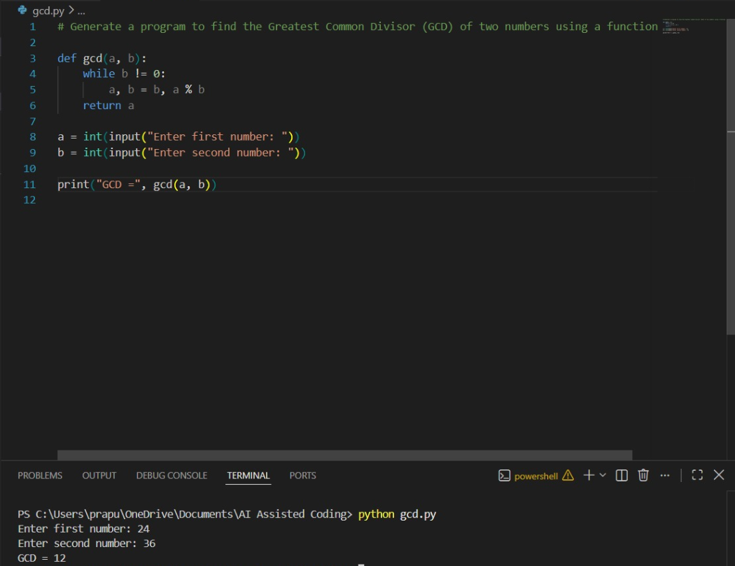

2.AI Tool Used: ChatGPT
Prompt: Generate a program to find the Greatest Common Divisor (GCD) of two numbers using a function

Input & Output:
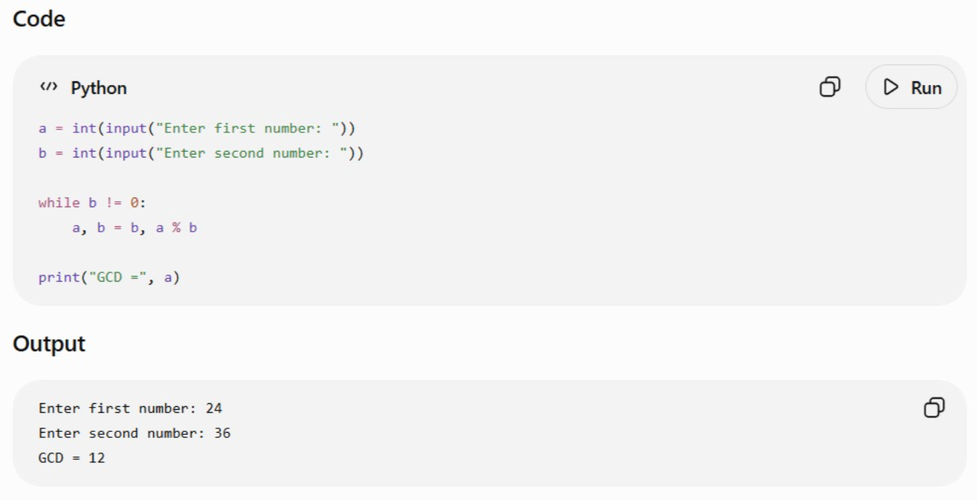

3.AI Tool Used: Google Gemini
Prompt: Generate a program to find the Greatest Common Divisor (GCD) of two numbers using a function

Input & Output:
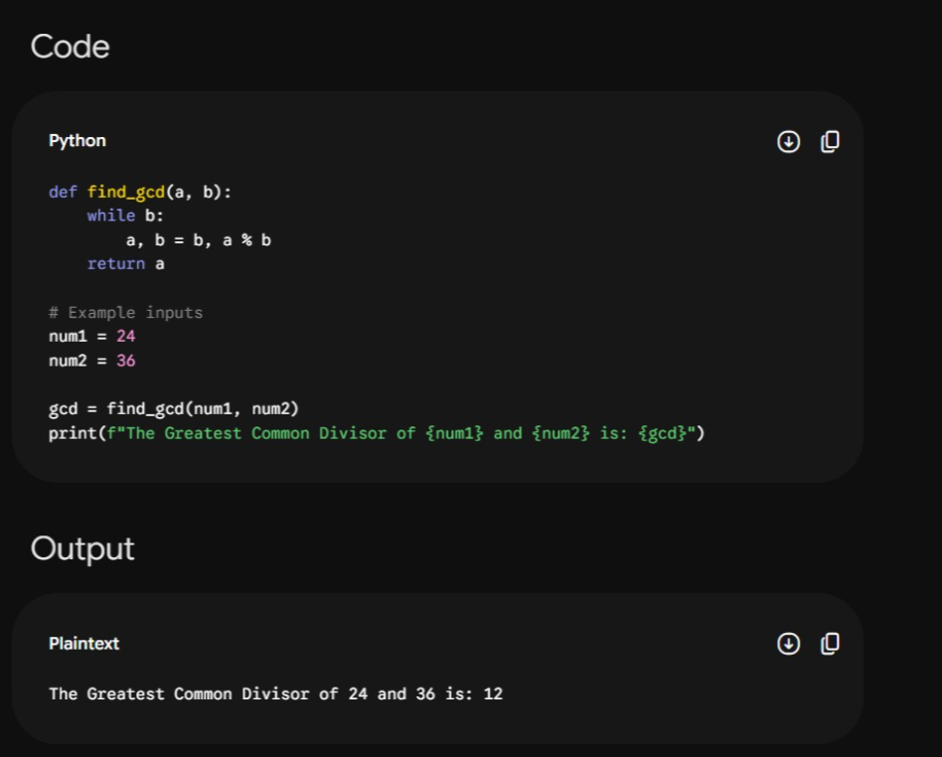

Comparision:
The 2nd code is the easiest and most beginner-friendly because it is short, simple, and directly takes user input.
The 1st code is better for practical use because it combines a function with user input and can be reused for different numbers.
The 3rd code is better for understanding functions and demonstrating a fixed example with a clear and descriptive output.

